Georeferencing Topo Sheets and Scanned Maps

QGIS Tutorials and Tips



Modified from: Ujaval Gandhi

<http://google.com/+UjavalGandhi>

**Georeferencing Topo Sheets and Scanned Maps**

Most GIS projects require georeferencing some raster data. Georeferencing is the process of assigning real-world coordinates to each pixel of the raster. Many times these coordinates are obtained by doing field surveys- collecting coordinates with a GPS device for few easily identifiable features in the image or map. In some cases, where you are looking to digitize scanned maps, you can obtain the coordinates from the markings on the map image itself. Using these sample coordinates or GCPs (Ground Control Points), the image is warmed and made to fit within the chosen coordinate system. In this tutorial, Ujaval Gandhi discusses the concepts, strategies and tools within QGIS to achieve a high accuracy georeferencing.

**Overview of the task**

We will use a scanned map of southern India from 1870 and georeferenced it using QGIS.

**Other skills you will learn**

How to determine datum and coordinate systems for old maps.

**Get the data**

[Hipkiss’s Scanned Old Maps](http://www.hipkiss.org/) website has an excellent collection of out-of-copyright scanned maps that one can use for research.

Download the [1870 map of southern India](http://www.hipkiss.org/data/maps/william-mackenzie_gallery-of-geography_1870_southern-india_3975_3071_600.jpg) and save it as a JPG image on the desktop of your hard drive.

For convenience, you may directly download a copy of the dataset from the link below:

[1870_southern_india.jpg](http://www.qgistutorials.com/downloads/1870_southern-india.jpg)

**Procedure**

1. Georeferencing in QGIS is done via the ‘Georeferencer GDAL’ plugin. This is a core plugin- meaning it is already part of your QGIS installation. You just need to enable it. Go to Plugins > Manage and Install Plugins and enable the Georeferencer GDAL plugin in the Installed tab. See Using Plugins for more details on how to work with plugins.



1. The plugin is installed in the Raster menu. Click on Raster > Georeferencer > Georeferencer to open the plugin.



1. The plugin window is divided into 2 sections. The top section is where the raster will be displayed and the bottom section where a table showing your GCPs will appear.



1. Now we will open our JPG image. Go to File > Open Raster. Browse to the downloaded image of the scanned map and click Open.



1. On the next screen, you will be asked to choose the raster’s coordinate reference system (CRS). This is to specify the project and datum of your control points. If you have collected the ground control points using a GPS device, you would choose the WGS84 CRS reference system. If you are geo-referencing a scanned map (such as the one of Southern India), you can obtain the CRS information from the map itself. Looking at our map image of Southern India, the coordinates are in Lat/Long. There is no datum information given, so we have to assume an appropriate one. Since it is India and the map is quite old, we can bet the Everest 1830 datum would give us good results. But, your best choice should always be WGS84 EPSG:4326.



1. You will see the image loaded in the top section.



1. You can use the zoom/pan controls in the toolbar to see the map better.



1. You now need to assign coordinates to some points on this map. If you look closely, you will see a coordinate grid with markings. Using this grid, you can determine the X and Y coordinates of the points where the grids intersect. But, you might not have a coordinate grid on your map. In this case, you will need to look for X (longitude) and Y (latitude) coordinates for places on the map. You can do this at [LatLong.net](http://www.latlong.net/). Once you are certain of your coordinates, click on Add Point in the toolbar.



1. Click on the spot on the map, where you would like to assign lat/long coordinates. In the pop-up window, you will enter these coordinates. Remember that the X=longitude and Y=latitude. Click OK. HINT: You should do this in a counter-clockwise direction on your map starting from the lower right-hand corner.



1. You will notice the GCP table now has a row with details of your first GCP.



1. Similarly, add at least 4 GCPs covering the entire image. The more points you have, the more accurate your image is registered to the target coordinates.



1. Once you have enough points, go to Settings > Transformation settings.



1. In the Transformation settings dialogue box, choose the following:
   1. Transformation type > Thin Plate Spline
   2. Name your file and path in the Output raster box
   3. Target SRS > EPSG:4326
   4. Load in QGIS when done > check
   5. OK



1. In the Georeferencer window, go to File > Start georeferencing. This will start the process of warping the image using the GCPs and creating the target raster (the georeferenced map).



1. Once the process finishes, you will see the georeferenced layer (map) loaded in QGIS. You can now check your work by going to the WEB menu and choosing one of the Open Layers Plugins.

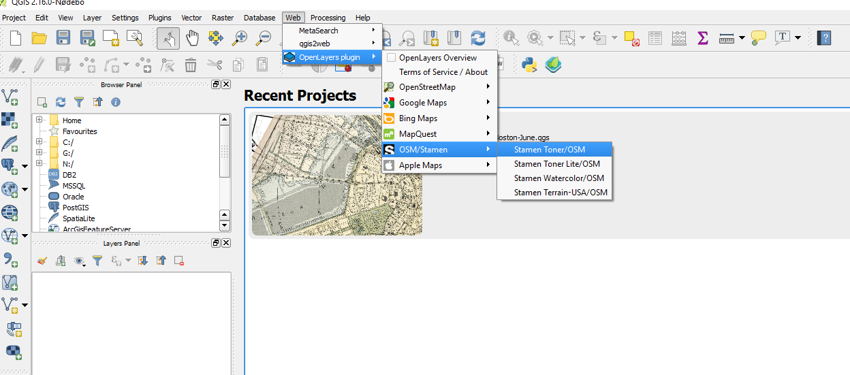

1. If you do not have the Open Layers Plugin installed in QGIS, you can find it at: Plugins ‣ Manage and install plugins ‣ Search ‣ Install Plugin

